Assignment 2

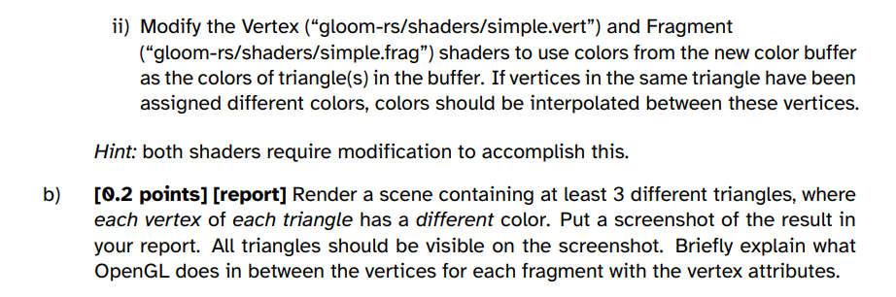

B) OpenGL uses interpolation between the vertex color attributes for each fragment. After the vertices are transformed and projected into screen space, OpenGL breaks down the triangles into fragments. The distances of these fragments from the triangle’s vertices are then used for calculating the interpolated color of the fragment. If a fragment is closer to red it will have a color value closer to red. If for example a fragment is equally as close to the red vertex as it is to the green one, it will get a color value of yellow since it will be an equal mix of the two colors. The result of this is a smooth transition between colors on the surface of the triangle giving an effect of a gradient between the vertices.

1. A blue triangle with green triangles

   Description automatically generated with medium confidence

Here it is clear that the the triangle closest to the screen dominates the part where all triangles intersect in the xy plane. The light blue colored triangle is the one closest to the screen and is thus affecting the final intersection area of all the triangles, making it more light-blue-ish, compared to the original dark blue-ish color.

1. A screenshot of a computer

   Description automatically generated

The overlapping area is covered because of the order of rendering and how the depth buffer is used. The first triangle to be drawn here is the blue triangle and since it was the first triangle to be drawn (no other values to test depth with), it is drawn as a non-transparent triangle. The second triangle to follow is the green triangle which is behind the first triangle, and the third triangle is the light blue triangle which is also covered by the blue triangle. This illustrates why the back to front rendering is important for transparent geometries.

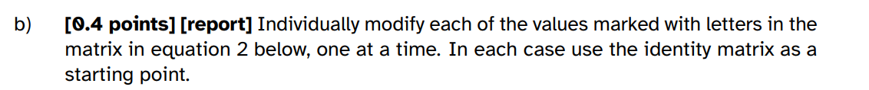

B)

a = scale in x direction

b = shear, with y coordinate not changing but x is being sheared

c = translation in x direction.

d = shear, with x not changing but y is being sheared

e = scale in y direction

f = translation in y direction



C) rotations happen around a point, and the distances of the vertices to that point are preserved when a rotation is applied. A rotation also requires 4 of the variables to be changing, since we were only moving one at a time, none of them were rotations.

# Task 4

W: Move forwards in z

A: Move towards left in x

S: Move backwards in z

D: Move towards right in x

Space: Move upwards in y

Left-Shift: Move downwards in y

Up: Rotate up in x

Down: Rotate down in x

Left: Rotate left in y

Right: Rotate right in y